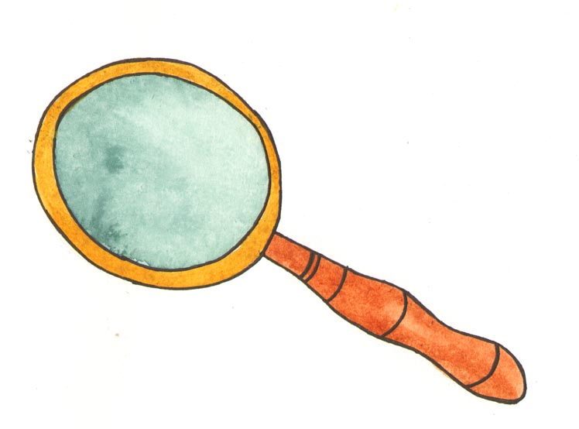

Proofreading your writing

The best way to begin proofreading is to read the essay out loud to yourself or have someone else read it to you. Try recording it onto your phone or computer and then playing it back. Listening to your writing will help you to spot things that might not make sense.You can also do this by using a free piece of software called NaturalReaders that you can download from http://www.naturalreaders.com/index.htm

Proofread in two stages: first for structure and then to check your writing skills.

Proofread for Structure

Read the paper through and then focus on the three divisions: introduction, main part and conclusion, asking yourself the following questions:

Introduction

Does it lead into the essay, explain what you are going to write about, and say what the main points will be?

Main Body

Does each paragraph have one point, which is introduced in the first line of that paragraph?
Is your point supported by evidence for example quotations?
Does the main body follow the plan laid out in the Introduction?

Conclusion
Is there a sense of an ending?
Have I offered a confident and persuasive conclusion?
Did I fall into the trap of repeating my introduction?

Proof read for writing skills

Content

- Does each sentence make sense?
- Any information missing?
- Will the reader know what I mean?
- Will the reader understand what I have written?
- Does it have a beginning, middle and an end?
- Have I used a particular word too often?
- Is there a better word I could use?

Spelling

- Look carefully at each word.
- Underline any that look wrong.
- Check the spelling with an online dictionary.

Punctuation

- Full stop at the end of a sentence - capital letter at the beginning of a sentence
- Is the sentence too long, does it need a comma or rewording
- Are apostrophes used correctly?
- Are any ‘?’ or ‘!’ needed?

Grammar

- Does every sentence have a subject and verb?
- Are the verbs the right tense (present, past, future)?
- Are adjectives and adverbs used correctly?

Assistive Technology

There is a Spelling and Grammar checker in Microsoft Word under the ‘Tools’ menu. It will give you alternative words for those highlighted as incorrect. The limitation of this is that it will not give dictionary definitions for those alternative words.

Read and Write software has a spelling and grammar checker and also provides the definitions of alternative words. It also has a homophone check for words that sound the same but have different spellings and meanings from each other. You can select an icon that will tell you the different meanings for ‘which’ and ‘witch’, and will make suggestions about the correct word if you have selected the wrong word in the context of your sentence.

For more information see the leaflet and podcast ‘Converting Text to Speech – Using Texthelp Read and Write Gold’.

Proofreading checklist

Content

• Does each sentence make sense?
• Any information missing?
• Will the reader know what I mean?
• Will the reader understand what I have written?
• Does it have a beginning, middle and an end?
• Have I used a particular word too often?
• Is there a better word I could use?

Spelling
• Look carefully at each word.
• Underline any that look wrong.
• Check the spelling with an online dictionary.

Punctuation
• Full stop at the end of a sentence - capital letter at the beginning of a
sentence
• Is the sentence too long, does it need a comma or rewording
• Are apostrophes used correctly?
• Are any ‘?’ or ‘!’ needed?

Grammar
• Does every sentence have a subject and verb?
• Are the verbs the right tense (present, past, future)?
• Are adjectives and adverbs used correctly?

